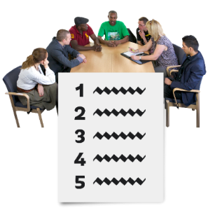
Wednesday 18th February 10:30am – 12:30pm
 | Agenda
  1. | Peer Workers  Welcome people in-person and online to the Reinforce Big Issues Group
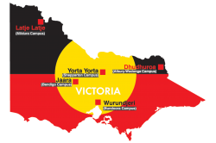  2.  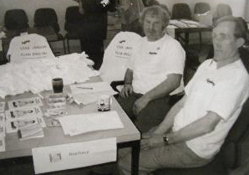 | Acknowledgement of Country –  We acknowledge the traditional owners of the land that we meet on, and we pay our respects to their elders past and present.  Recognising self-advocates -  We recognise self-advocates who have worked tirelessly over the years for the right to live in the community and for equality and human rights for all.
  3. | Who is here?  Apologies?
  4.    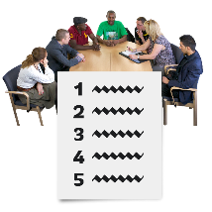     | How to Have Good Meetings:  - Listen to each other and don’t talk over each other.  - Put up your hand if you want to speak.  - Please stick to the agenda – you can chat after the meeting!  - If there is anything that upsets you from this meeting. You could either let someone know or go step out of the room.  - Keep other people’s information confidential.
5. (approx 10:45)  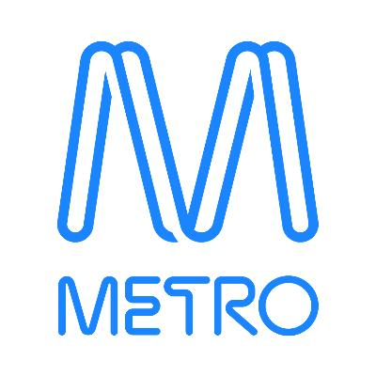 | Today’s Topic: Public Transport and Metro  Today we are talking about Public Transport in Melbourne.  Verity and Jackie are here from Metro to talk about the new tunnel and the work Metro does to make public transport accessible in Melbourne.
  6. (approx. 11:15) | Questions about the presentation:  Raise your hand if you want to ask a question.  Start by sharing your name.
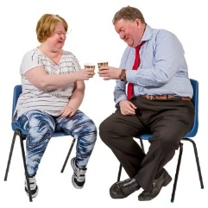  7. (approx. 11:30) | Tea Break
8. (approx. 11:45)  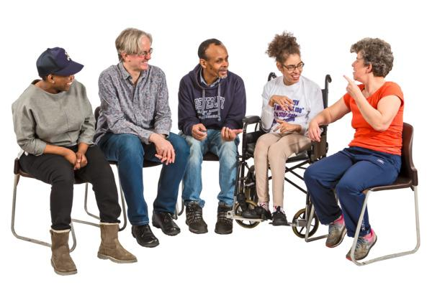 | Discussion on Public Transport:  Opportunity for anyone to share their experiences of using public transport.  What could be done to make public transport in Melbourne more accessible?  What should Reinforce do next?

